***Assignment –6***

Using Special Operators in Conditions.

1. Write two different queries that would produce all orders taken on October 3rd or 4th, 1990.

Ans 1) 1st query 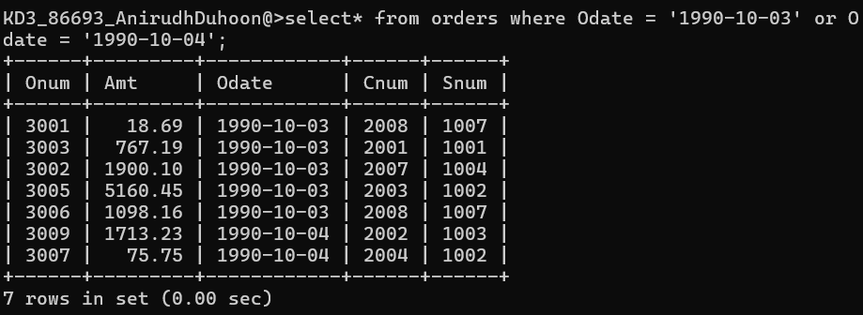

2nd query 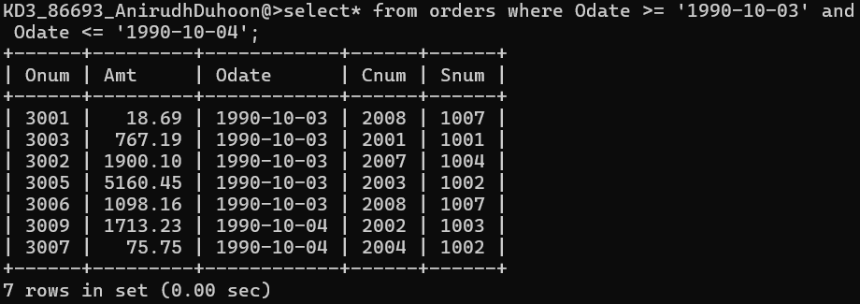

1. Write a query that selects all of the customers serviced by Peel or Motika. (Hint: the snum field relates the two tables to one another).

Ans 2)

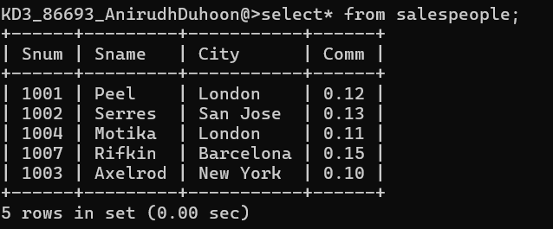

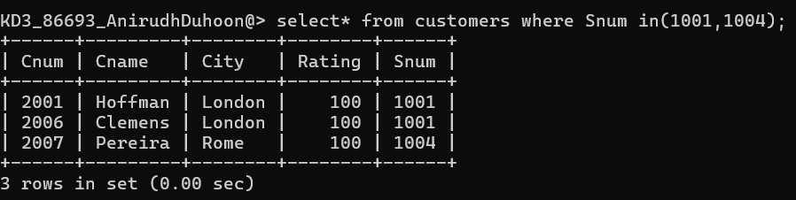

1. Write a query that will produce all the customers whose names begin with a letter from ‘A’ to ‘G’.

Ans 3)

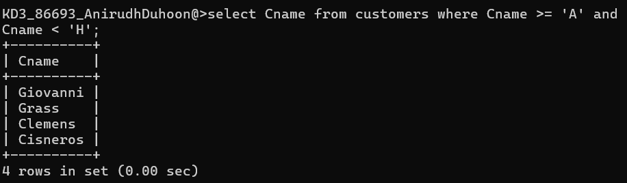

1. Write a query that selects all customers whose names begin with the letter ‘C’.

Ans 4)

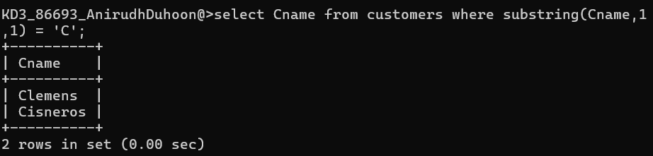

1. Write a query that selects all orders except those with zeroes or NULLs in the amt field.

Ans 5)

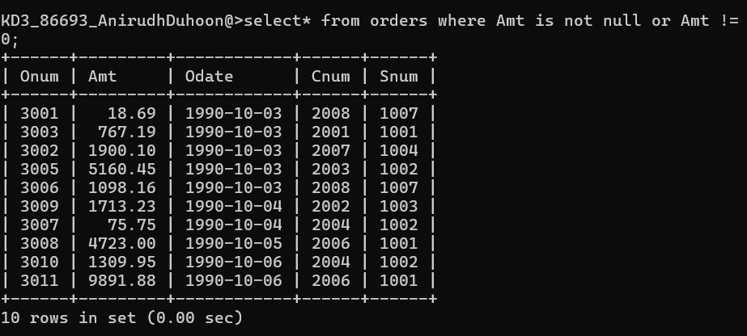

*Sameer Dehadrai* Page: 1